California Public Utilities Commission Energy Division Staff Comments on CAISO’s Business Practice Change Proposed Revision Request 1498

The California Public Utilities Commission (CPUC) Energy Division Staff (“ED staff”) appreciates the opportunity to comment on CAISO’s Business Practice Manual (BPM), Proposed Revision Request (PRR) 1498 regarding Assistance Transfer Energy. In BPM PRR 1498, CAISO proposes to implement criteria under which it would opt the CAISO balancing area authority (BAA) into its proposed Western Energy Imbalance Market (WEIM) energy assistance program. CAISO developed this energy assistance program over the past year, and filed it with the Federal Energy Regulatory Commission (FERC) on March 31, 2023, requesting approval for implementation on June 1, 2023.
While ED staff does not oppose CAISO’s proposed WEIM energy assistance program per se, ED staff does not support the CAISO BAA opting into the program on behalf of California load serving entities, at this time. ED staff’s position is discussed in more detail below, after a more detailed discussion regarding the genesis and development of this proposal and comments made by parties in the CAISO BAA throughout the stakeholder process.
Background
Broadly, the resource sufficiency evaluation (RSE) is a test conducted by CAISO to ensure that WEIM entities have sufficient capacity and flexibility to meet their load (and certain export obligations), before allowing CAISO to optimize resources through the WEIM process. Currently, if an entity fails the WEIM RSE, that balancing authority area (BAA) is limited to WEIM transfers based on the last feasible schedule. Thus, if an entity had net WEIM transfers of 1,000 MW before failing the RSE in the next interval, that BAA would be limited to WEIM transfers of 1,000 MW.
Over the past year, CAISO has worked on an energy assistance proposal at the request of a number of external, non-California WEIM participants. These entities primarily expressed concern that limiting WEIM transfers to the last feasible schedule could result in reliability events and/or exacerbate stressed system conditions. Others, however, expressed concerns that the CAISO BAA had access to any WEIM transfers after an RSE failure, even though CAISO typically supports low priority exports based on advisory WEIM transfers in the hour-ahead scheduling process (HASP).
CAISO initially developed an energy assistance proposal that would increase prices up to $4,000/MWH for all real-time transactions when a WEIM entity failed the RSE, if a WEIM entity opted into the energy assistance product. This proposal was nearly universally opposed. The opposition was based on the high proposed price, but especially because it did not impose this price on just the incremental amount of energy needed to meet an entities resource sufficiency evaluation. In other words, this high proposed price would apply to the entire real-time market – an extraordinarily expensive proposition.
For example, under this paradigm, if a BAA failed the RSE by 1 MW (and, thus, arguably only needed 1 MW to meet load), but had 3,000 MW of real-time transactions, prices could rise to $4,000/MWh for all 3,000 MW of real-time market transactions, not just the 1 MW failure. The extraordinarily high cost of this proposal was demonstrated by the Department of Market Monitoring (DMM) in its comments on that version of CAISO’s proposal (see table below).
Under this proposal, as demonstrated by DMM, the CAISO would have paid a penalty of $60 million for RSE failures in 15 fifteen minute intervals (or over 3 ¼ hours), in addition to the $46 million paid for the energy itself, at an average price of $1,534/MWh, even before consideration of the proposed $2,000/MWh in-market scarcity pricing penalty.
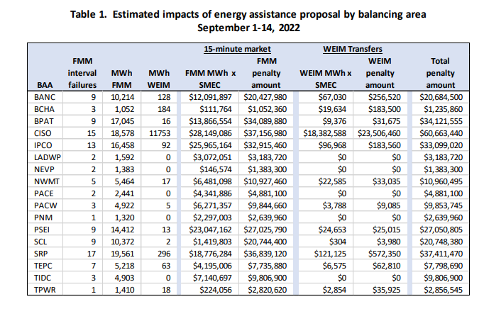
After considering stakeholder comments, CAISO revised the final version of the RSE. In its final version, currently before FERC for consideration, CAISO proposes, for those BAAs opting into the program, an after-the-fact charge of either $1,000 or $2,000/MWH (depending on the price cap in place at the time), multiplied by the lesser of 1) the WEIM RSE failure amount, or 2) the dynamic WEIM transfers that are tagged. These charges would be in addition to any of the charges for the energy itself. Thus, for example, if a BAA failed the RSE by 1,500 MW, but had 3,000 MW of WEIM transfers over the course of an hour, the after-the-fact charge would be $3 million (or $2000/MWH x 1,500 MW), in addition to energy payments up to $6 million if the price cap of $2,000/MWH was in effect at that time. At the same time, if a BAA failed the RSE by 1,500 MW, but had no WEIM transfers, the BAA would still be assessed the after-the-fact charge of $3 million, simply based on the RSE failure, not based on the incremental WEIM transfer usage.
Many entities supported the CAISO’s final proposal and agreed that it should be opt in, while others argued that it should be mandatory for all BAAs and that the charges should apply to all WEIM transfers after failure, not just the RSE failure amount. Most stakeholders representing CAISO load felt strongly that CAISO should hold a formal stakeholder process before opting in. These various stakeholder positions are illustrated in some excerpts from comments below:
- Southern California Edison:
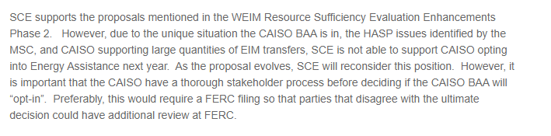
- SDG&E:
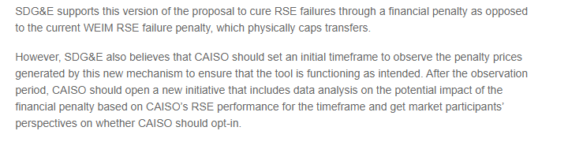

- PG&E:
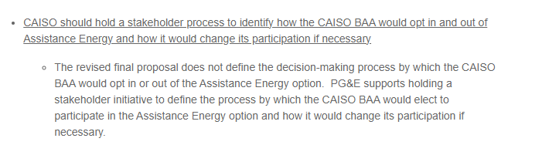
Non-CAISO load generally supported the initial RSEE Phase 2 proposal, as represented by the comment below:
- PowerEx:
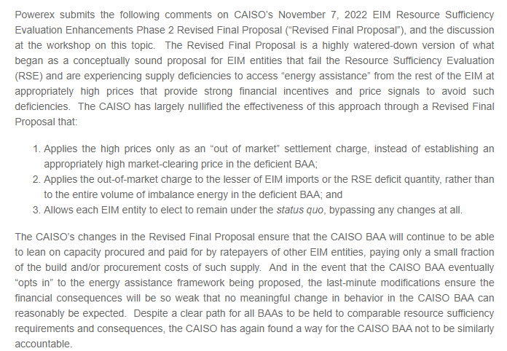

Primarily in response to entities that have argued that the failure consequences should be mandatory (e.g., PowerEx), CAISO proposed in its tariff filing to sunset this energy assistance program on December 31, 2025 and committed to considering a mandatory in-market program in its RSE Phase 3 initiative. In its memo to its Board, CAISO stated that a minority of stakeholders oppose the proposed assistance energy product being applied after-the-fact, maintaining that “the proposed design lessens the financial consequences of a balancing authority area may be exposed to resulting from being insufficient.” CAISO noted that it while it “agrees with this sentiment,” it did not believe additional changes could be implemented by summer of 2023 and indicated that, “[m]anagement intends to explore a more robust assistance solution that is priced through the market in a subsequent stakeholder process.”
ED Staff Oppose CAISO Opting into the Energy Assistance Program Through this BPM Process
ED staff has concerns with CAISO opting into the energy assistance program through this BPM process for a number of reasons, discussed further below.
Violates Rule of Reason
First, the determination of whether and when CAISO will opt into the energy assistance program violates the rule of reason policy, which requires that all practices that significantly affect rates, terms and conditions of service to be on file with FERC, since the decision of whether and when to opt into the energy assistance program significantly affects the rates, terms, and conditions of service, and any modifications that CAISO makes to the conditions of whether and when CAISO should opt into the energy assistance program could also affect rates, terms, and conditions. Under FERC’s rule of reason policy, provisions that “significantly affect rates, terms, and conditions of service, are readily susceptible of specification, and are not generally understood . . . must be included in the Tariff.” In contrast, “items better classified as implementation details may be included only in the business practice manual[s].” Whether and when to opt into an energy assistance program is not just an implementation detail, because it will affect when and how much customers will pay, what they will be paying for, and under what conditions they will be subject to these penalties. Thus, this not an implementation detail that can be included in CAISO’s BPM.
Results in Double Payment
Second, ED staff disagrees with CAISO opting into this program at this time because we are concerned about the accuracy of the RSE test itself and the high likelihood in double payments based on the current RSE test design. In particular, ED staff is concerned because the CAISO RSE does not explicitly take into account the CPUC’s reliability Base Interruptible Program (BIP) that its customers are paying for and that are typically available to the CAISO during stressed system conditions, precisely those conditions under which CAISO might fail the RSE and during which these penalty provisions could apply.
For example, assume the CAISO has 1,000 MW of BIP that is only activated in an EEA-2, but at 2 pm, CAISO anticipates an EEA-2 at 5 pm, activates BIP at 5 pm and calls an EEA-2 at 5 pm. In this case, the 5, 5:15, 5:30, and possibly the 5:45 RSE would not include the BIP program, since the RSE test occurs at T-40, or before the hour in question and before the BIP is activated. Under these circumstances, the CAISO could fail the RSE by 1,000 MW and subsequently pay $2,000 MWH or $2 million, even though it had resources to meet its load (in the form of BIP itself). In this case, CAISO would activate the BIP, potentially pay the resource at the $2 million at the bid cap and also incur $2 million in penalties, which constitutes a double payment.
This treatment and concern would be equally applicable for any other strategic reserve resources or additional real-time imports procured through out-of-market and emergency energy purchases that are under contract but are not represented in CAISO’s bid stack. ED staff notes that CAISO could access strategic reserves in other BAAs by way of additional real-time imports through out-of-market and emergency energy purchases, even if WEIM transfers were limited, because these are not WEIM transfers themselves. The figure below illustrates the out-of-market and emergency purchases that CAISO made during the September 2022 stressed system conditions.
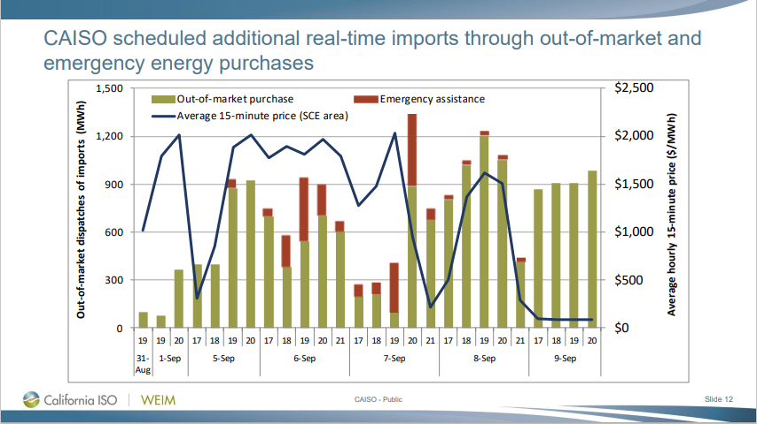
Source: RIF Market Conditions for September 2022 presented November 8, 2022 (caiso.com), p. 12.
The emergency assistance penalty provisions nearly guarantee CAISO will pay twice if the CAISO BAA fails the RSE because of failure to include RDRR, strategic reserve resources, and/or out-of-market and emergency energy purchases and then CAISO deploys these resources themselves and does not need any additional WEIM transfers. Such double payments are not just and reasonable.
In addition, ED staff is concerned that the BIP treatment is discriminatory because CAISO allows other BAAs to adjust their load forecast to account for their demand response, whereas CAISO appears to impose more stringent conditions before activating the CPUC-jurisdictional BIP program. That is, currently, CAISO will only activate the BIP at an EEA2, but appears to allow other BAAs to adjust their load forecasts for their emergency demand response at any point, not requiring activation of an EEA2 before this occurs. This discriminatory treatment is yet another reason that ED staff opposes opting into the CAISO’s proposed energy assistance program.

Provides No Clear, or Incremental Benefit
Third, ED staff opposes opting into the energy assistance program at this time because it provides no clear benefit. Under the current paradigm, BAAs that fail the RSE are limited to the last feasible WEIM transfer schedule. However, because CAISO WEIM scheduled transfers are so much larger in the 15-minute market than the actual transfers realized in the binding 5-minute market, limiting CAISO to the last feasible 15 minute schedule is not binding. This is illustrated in the figure below.

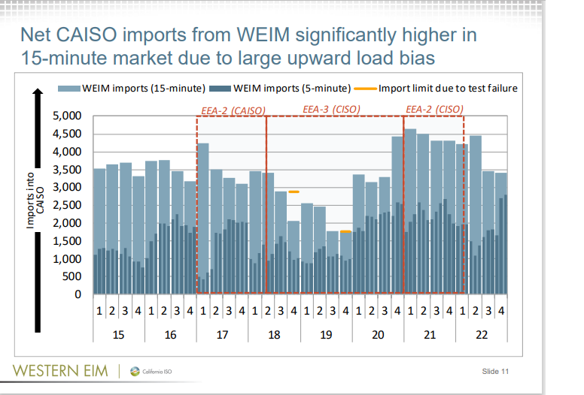
Source: DMM Presents WEIM Resource Sufficiency Tests (caiso.com), p. 11.
In addition, ED staff notes that while CAISO was receiving 1,000 MW of actual WEIM transfers during the EEA3 (see the 5 minute WEIM imports shown above), the CAISO BAA was also supporting LPT exports during the EEA3 as well, as illustrated in the figure below.

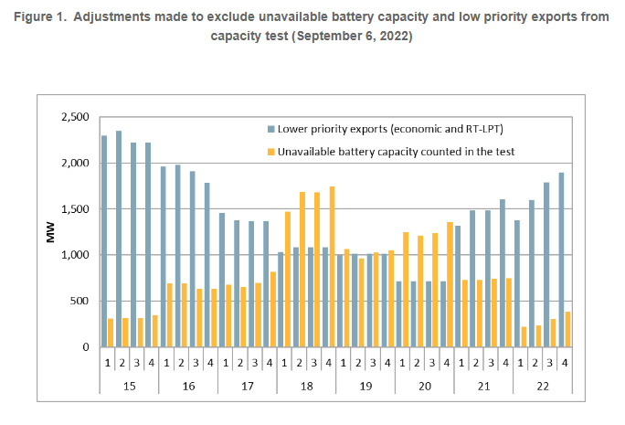
Source: https://stakeholdercenter.caiso.com/Common/DownloadFile/40299f19-b952-4ac5-815b-3159a047d512, p. 3.
Finally, ED staff notes that the load conformance adjustments that result in high 15-minute WEIM transfers, but lower 5-minute WEIM transfers in and of themselves, already result in higher costs for California customers. As noted by the CAISO’s Market Surveillance Committee in its RSE Phase 1 opinion,
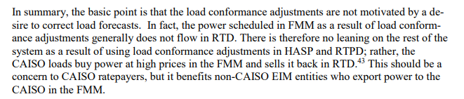
Further, prices in the FMM are systematically higher in the FMM than the RTD, as is illustrated in the following figure.

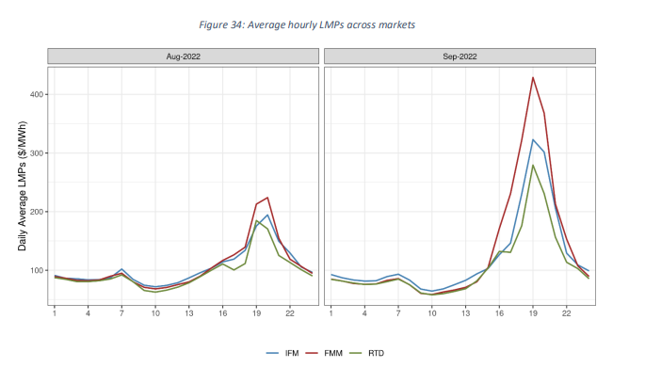
Source: SummerMarketPerformanceReportforSeptember2022.pdf (caiso.com), p. 54.
In summary, ED staff is unclear how opting into this program will benefit customers within the CAISO because the current provisions are not binding, and these customers are already paying extraordinary prices for energy through the WEIM that is often sold back at lower prices in the RTD. This will presumably continue under CAISO’s proposed energy assistance program, creating additional complexity and cost that does not appear necessary or reasonable.
Issues with the RSE Calculations Itself Makes the Energy Assistance Penalty Provisions Unjust and Unreasonable
ED staff opposes opting into this program at this time because of a variety of other concerns regarding the RSE itself, including the effect of day-ahead LPT exports in the test, the uncertainty component, among and other issues.
Day-ahead LPT exports. CAISO proposes to include day-ahead LPT exports in CAISO’s RSE. ED staff is concerned that this could result in CAISO failing the RSE, even though those LPT exports can be curtailed in real-time. In particular, ED staff notes that in September 2022, CAISO cleared day-ahead LPT exports at the same time that CAISO was in EEAs during the days in question (see figures below). ED staff is unclear and concerned as to how this could happen and what would prevent this from occurring. ED staff has made a request for CAISO to provide additional information in response to this concern.
Inclusion of the day-ahead LPT exports in the RSE test contributes to the potential for CAISO BAAs to fail the RSE test and be subject to penalties. In this instance, CAISO could fail the RSE because of day-ahead LPT exports, and pay penalties, even though CAISO could cut the LPT exports to avoid a failure of the RSE. For example, assume CAISO is resource sufficient, except for 1,000 MW of intertie imports supporting day-ahead LPT exports, that clear RUC and HASP, but at that point the intertie goes down. CAISO fails the RSE because it proposes to include day-ahead LPT RUC and HASP cleared exports, and must pay a penalty, even though the CAISO BAA was itself resource sufficient. Thus, these penalties are not following cost-causation principles, in that they are imposed broadly on customers within CAISO and not on LPT exports that potentially cause the RSE failure in the first place.
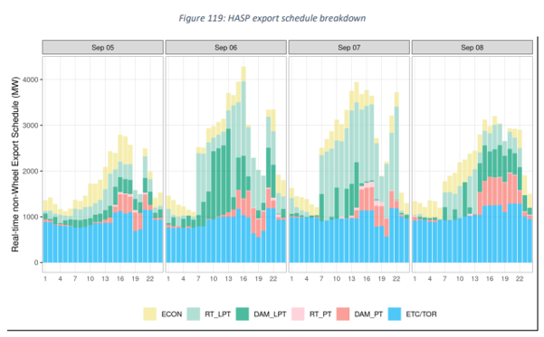
Source: SummerMarketPerformanceReportforSeptember2022.pdf (caiso.com), p. 128.

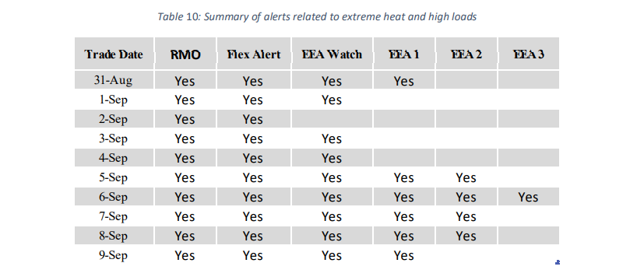
Source: SummerMarketPerformanceReportforSeptember2022.pdf (caiso.com), p. 101.

Uncertainty. CAISO has proposed that the uncertainty component be included in the RSE after the revised uncertainty calculation in the flexible ramping product (FRP) is implemented and understood. This uncertainty can increase the CAISO BAA’s RSE requirement by up to 2,000 MW in some hours. This could result in adversely affecting CAISO’s ability to pass the RSE. Some stakeholders have indicated that because of the way it is formulated, the uncertainty component will be volatile. For example, DMM has stated that “even with more testing, the quantile regression method that will be used to calculate the uncertainty adder included in the test will fluctuate significantly interval by interval, making it difficult for balancing areas to reproduce or predict in advance,” and that as a result, “DMM continues to recommend that the ISO and stakeholders consider developing much simpler and more transparent uncertainty adders in the next phase of this initiative.”
ED staff’s concern here is that the effect of the uncertainty adder on RSE failures is currently unknown. Thus, ED staff’s position is that it is unjust and unreasonable to opt into the energy assistance program without understanding all of the potential costs and benefits, including consideration of as-yet-to be quantified uncertainty requirements.

Other Design Flaws
Finally, ED staff disagrees with CAISO opting into the program because of the current shortfalls in the RSE design and implementation. As noted by CAISO in its Summer Market Performance Report, there were a number of reasons that the RSE test did not accurately reflect capacity available to the CAISO during stressed system conditions. These reasons are summarized as follows: 1) the capacity resulting from arming load in EEA3 was not counted the RSE; 2) more capacity was available from MSG transitions than was reflected in the test; 3) the ETC/TOR did not properly register as a wheel, so less capacity was actually available than was included in the test (and the export cut was reversed after the test); 4) storage resources were inaccurately modeled to include ancillary service capacity; 5) DC losses were not included in the test; 6) emergency imports and exports were not included in the test (discussed above), 7) the test did not reflect curtailments of HASP imports instituted by other BAAs or HASP imports that failed to deliver; 8) the test excluded LPT exports that should have been cut in the HASP process; and 9) the test included some MSG that was not available.
Summary of ED Staff’s Position
In conclusion, for the reasons set forth above, ED staff opposes the CAISO BAA defaulting into this program at this time.

https://stakeholdercenter.caiso.com/Common/DownloadFile/ea6aaf44-b3c6-46d3-9f53-998074a86e28, p. 4.
Available at California ISO - All comments (caiso.com).
Id.
Id.
Id.
https://www.caiso.com/Documents/DecisiononResourceSufficiencyEvaluationEnhancementsPhase2-Memo-Dec2022.pdf, p. 7.
Id. at pp. 7-8.
Energy Storage Assoc. v. PJM Interconnection, L.L.C., 162 FERC ¶ 61,296, at P 108 (2018).
Id.
MSCFinalOpiniononEIMResourceSufficiencyEvaluationEnhancements-Phase1.pdf (caiso.com), p. 20.
https://stakeholdercenter.caiso.com/Common/DownloadFile/44f0dacd-41ce-4fdc-9ff2-a9e070dc796b
SummerMarketPerformanceReportforSeptember2022.pdf (caiso.com), pp. 113 – 116.

